

CSE – 3002

Internet and Web Programming

LAB – 9



Question – 1

Show the Jquery effects hide() and show() for p tags with various selectors.

HTML Code

<html lang="en">

<head>

    <meta charset="UTF-8">

    <meta http-equiv="X-UA-Compatible" content="IE=edge">

    <meta name="viewport" content="width=device-width, initial-scale=1.0">

    <title>jquery start</title>

</head>

<body style="margin: 50px; border: 2px solid;">

    <p> <strong>jQuery</strong> is a JavaScript Library </p>

    <p> <strong>jQuery</strong> greatly simplifies JavaScript programming </p>

    <p> <strong>jQuery</strong> is easy to learn </p>

    <button class="show"> Display all </button>

    <button class="hide"> Hide all </button>

    <script src="https://ajax.googleapis.com/ajax/libs/jquery/3.5.1/jquery.min.js"></script>

    <script src="index.js"></script>

</body>

</html>

JS Code

$(document).ready(function(){

    let count = 0;

    $("p").css({"margin" :"30px" , "font-size" : "25px"});

    $(".show").css({"margin-left" : "30px","font-size" : "20px"});

    $(".hide").css({"margin-left" : "30px","font-size" : "22px"});

    $("p").click(function(){

        $(this).hide();

        count++;

    });

    $(".show").click(function(){

        $("p").show();

        $(".show").css("margin-top","30px");

    });

    $(".hide").click(function(){

        $("p").hide();

        $(".show").css("margin-top","30px");

    });

    if (count === 3)

    {

        $(".show").css("margin-top","30px");

    }

});

Output

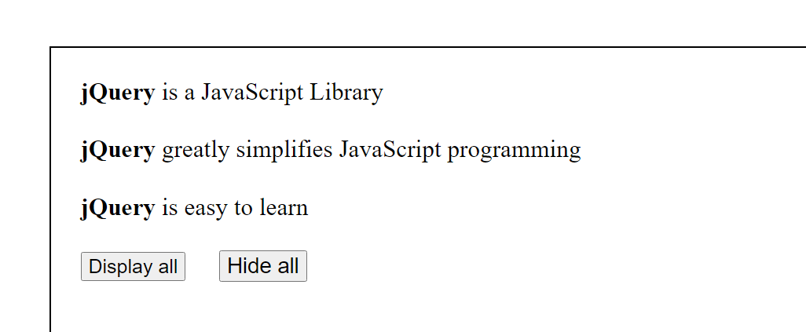

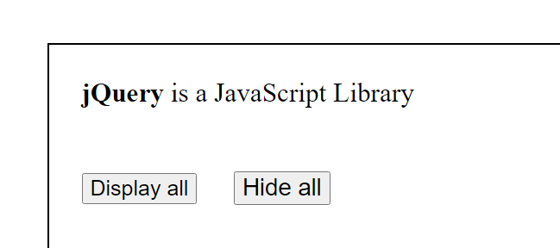

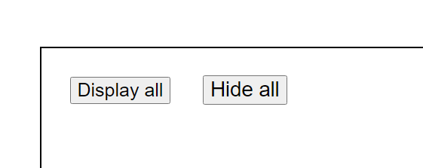

Question – 2

Show the usage of jquery with text() and html() methods for set/get options.

HTML Code

<html lang="en">

<head>

    <meta charset="UTF-8">

    <meta http-equiv="X-UA-Compatible" content="IE=edge">

    <meta name="viewport" content="width=device-width, initial-scale=1.0">

    <title>jquery start</title>

</head>

<body style="margin: 50px; border: 2px solid;">

    <p id="test" style="font-size: 20px; margin: 25px;">Random text to display</p>

    <hr>

    <h1>Text function</h1>

    <button style="font-size: 20px; margin-top: 20px; margin-left: 20px;" class="button1">Click this to enter your name</button>

    <p class="p1"></p>

    <hr>

    <h1>HTML function</h1>

    <button style="font-size: 20px; margin-top: 20px; margin-left: 20px;" class="button2">Click this to enter your college</button>

    <p class="p2"></p>

    <hr>

    <div style="margin: 30px;">

        <button id="btn1" style="font-size: 20px;"> Show text </button>

        <button id="btn2" style="font-size: 20px;"> Show HTML </button>

    </div>

    <script src="https://ajax.googleapis.com/ajax/libs/jquery/3.5.1/jquery.min.js"></script>

    <script src="index2.js"></script>

</body>

</html>

JS Code

$(document).ready(function(){

    $("#btn1").click(function(){

        alert("Text: "+$("#test").text());

    });

    $("#btn2").click(function(){

        alert("Text: "+$("#test").html());

    });

    $("h1").css({"margin-left" : "30px", "margin-top" : "30px"})

    $(".button1").click(() => {

    var name = prompt("Enter your name : ");

        alert("Given Name is : " + name);

        $(".p1").text("Your name is : " + name);

        $(".p1").css({"font-size" : "25px" , "margin-left" : "30px"})

    });

    $(".button2").click(() => {

        var college = prompt("Enter your college : ");

        alert("Given college is : " + college);

        $(".p2").html("Your college is : " + "<strong>" + college + "</strong>");

        $(".p2").css({"font-size" : "25px" , "margin-left" : "30px"})

    });

}

);

Output

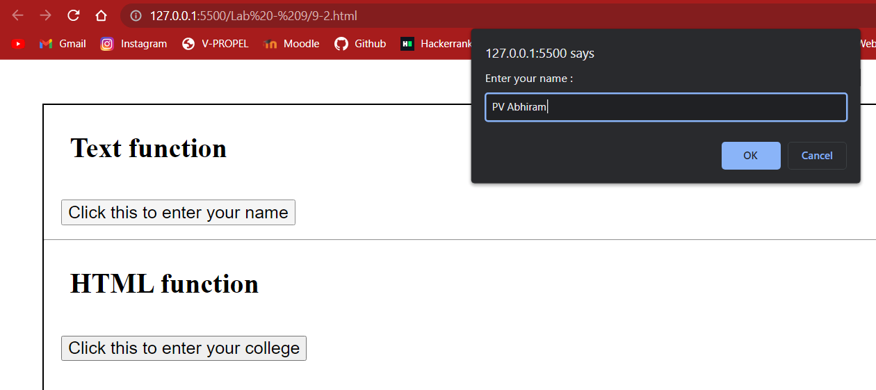

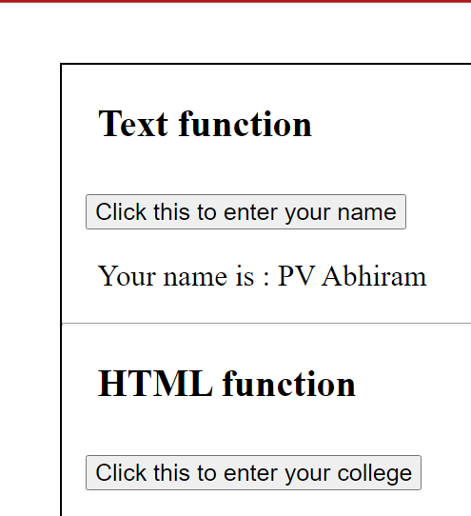

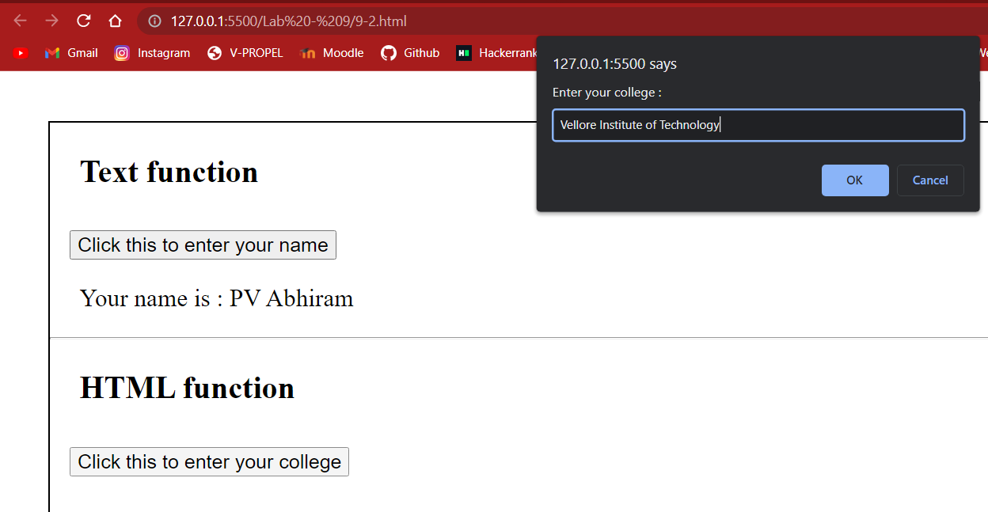

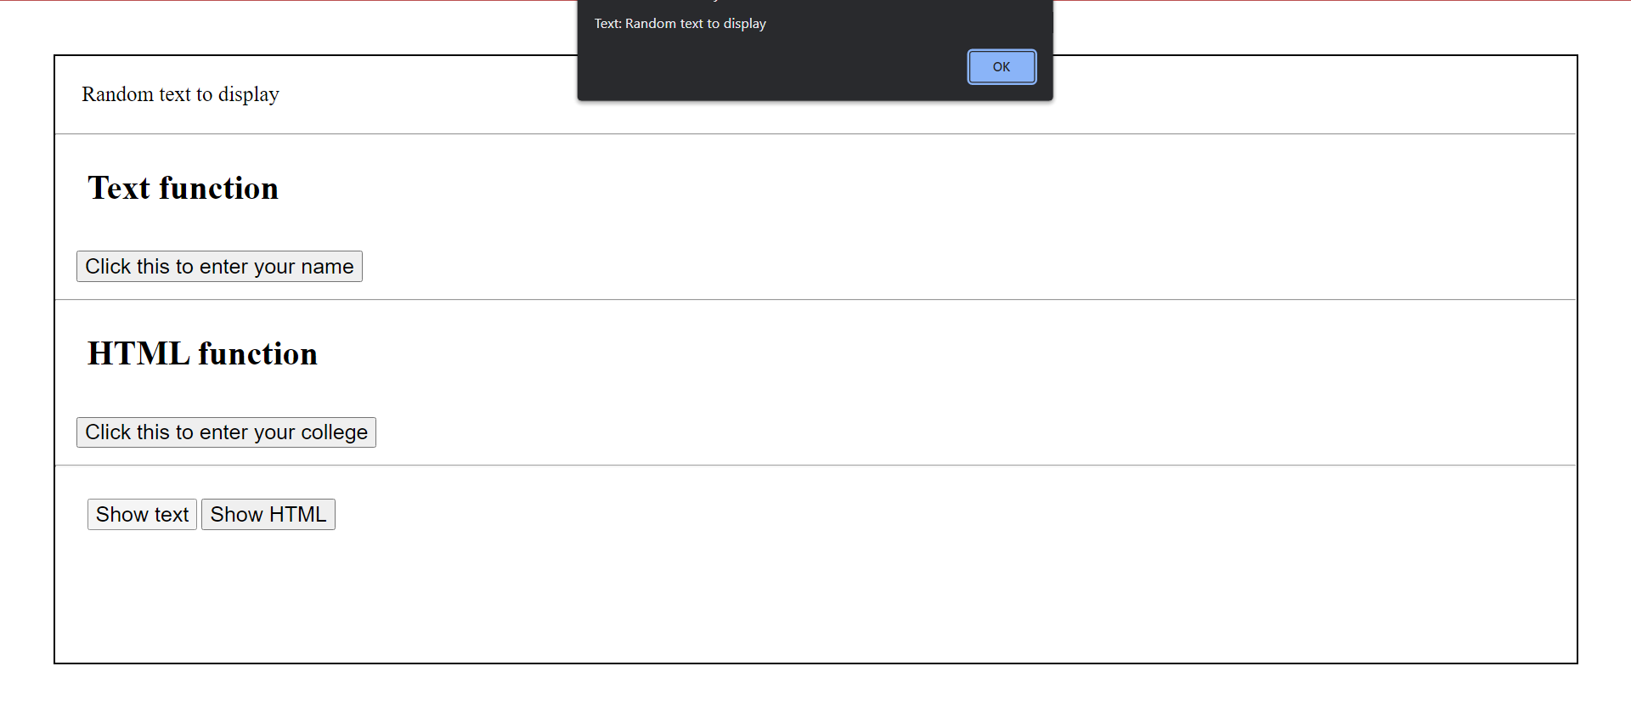

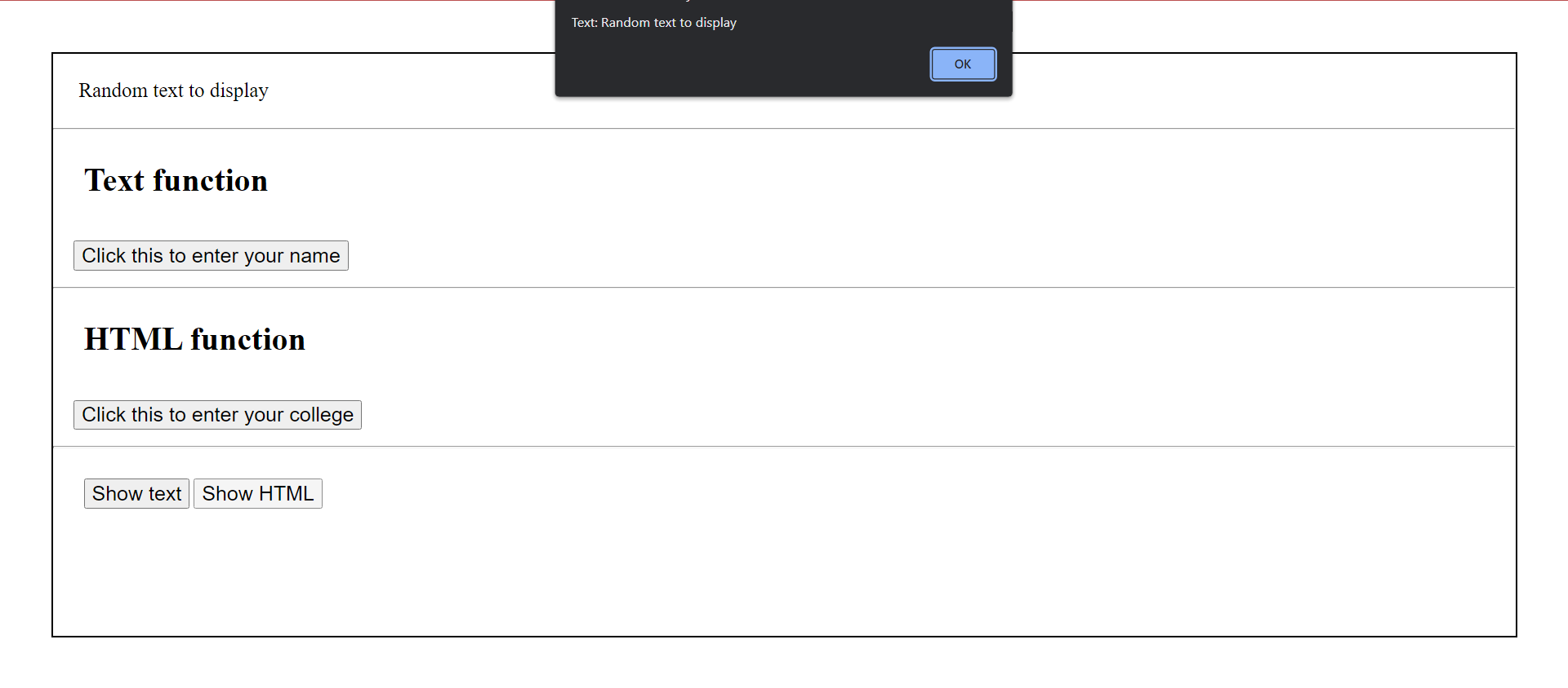

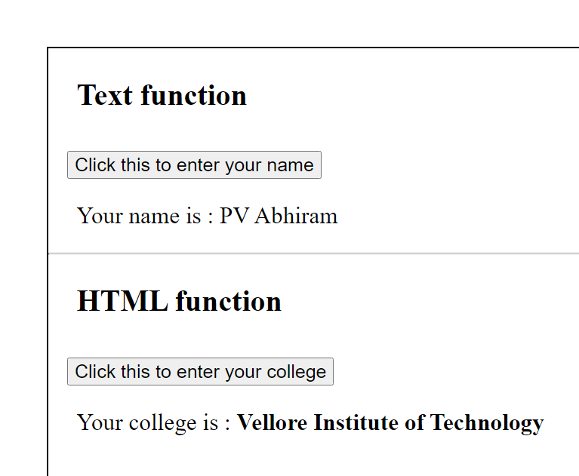

Question – 3

Read a number from the user and display the highest even and odd digits of the number in the click event of the button. Implement the same using jquery with appropriate html code.

Then throw the exception if the odd digit is highest digit.  
123456 -> highest even digit – 6  
Highest odd digit -5  
Compare 6 and 5 - > throw if odd highest digit is higher than even highest digit.

HTML Code

<html lang="en">

<head>

    <meta charset="UTF-8">

    <meta http-equiv="X-UA-Compatible" content="IE=edge">

    <meta name="viewport" content="width=device-width, initial-scale=1.0">

    <title>jquery start</title>

</head>

<body style="margin: 50px; border: 2px solid;">

    <div style="margin: 20px; font-size: 22px;">

        Enter the number : <input type="text" class="t1">

        <button class="b1" style="font-size: 15px;">Submit the number</button>

    </div>

    <p class="p1"></p>

    <script src="https://ajax.googleapis.com/ajax/libs/jquery/3.5.1/jquery.min.js"></script>

    <script src="index3.js"></script>

</body>

</html>

JS Code

$(document).ready(function(){

    $(".b1").click(() => {

        try {

            var number = $(".t1").val();

            var nums = [];

            for (let i = 0 ; i < number.length - 1 ; i++)

            {

                let num = parseInt(number.slice(i,i+1));

                nums.push(num);

            }

            nums.push(parseInt(number[number.length - 1]))

            let evenmax = -1,oddmax = -1;

            for (let i = 0 ; i < nums.length; i++)

            {

                if (nums[i] % 2 === 0)

                {

                    if (evenmax < nums[i])

                    {

                        evenmax = nums[i];

                    }

                }

                else

                {

                    if (oddmax < nums[i])

                    {

                        oddmax = nums[i];

                    }

                }

            }

            $(".p1").html("Highest even digit is : " + evenmax + "<br>" + "Highest odd digit is : " + oddmax);

            $(".p1").css({"font-size" : "22px" , "margin-left" : "30px"})

            if (oddmax > evenmax)

            {

                throw "Odd digit is highest digit."

            }

        } catch (error) {

            alert("Message from exception handling : " + error)

        }

    });

});

Output

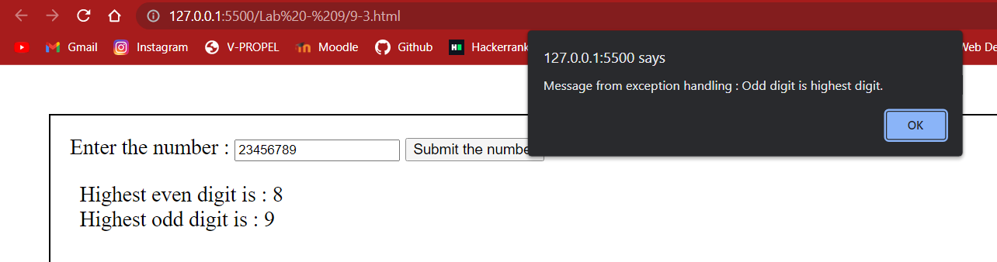

Thank you ma’am , Pinni Venkata Abhiram 20BAI1132